Query Processor

🧠 What Is a Query Processor in a DBMS?
# Source: AI Source: Provided by: [Data Path: Persons Table -> ID Column: 1, Name_En Column: Motasem Essam] -> From: [ChatGPT] on [6/10/2026]
The Query Processor is the component of a Database Management System (DBMS) that is responsible for receiving, analyzing, planning, and executing SQL queries.
It's like the brain that interprets your SQL commands, figures out the best way to execute them, and then tells the database engine what to do.

🔍 What Does the Query Processor Do?
# Source: AI Source: Provided by: [Data Path: Persons Table -> ID Column: 1, Name_En Column: Motasem Essam] -> From: [ChatGPT] on [6/10/2026]
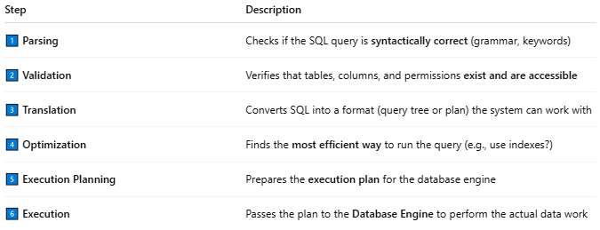
Step | Description
1️⃣ Parsing | Checks if the SQL query is syntactically correct (grammar, keywords)
2️⃣ Validation | Verifies that tables, columns, and permissions exist and are accessible
3️⃣ Translation | Converts SQL into a format (query tree or plan) the system can work with
4️⃣ Optimization | Finds the most efficient way to run the query (e.g., use indexes?)
5️⃣ Execution Planning | Prepares the execution plan for the database engine
6️⃣ Execution | Passes the plan to the Database Engine to perform the actual data work

⚙️ Example Flow
# Source: AI Source: Provided by: [Data Path: Persons Table -> ID Column: 1, Name_En Column: Motasem Essam] -> From: [ChatGPT] on [6/10/2026]
Let’s say you run:
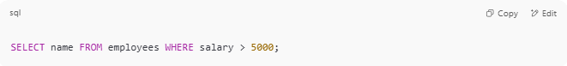
SELECT name FROM employees WHERE salary > 5000;

The Query Processor:
- Parses the SQL
- Checks if the employees table and name/salary columns exist
- Optimizes the query — maybe it uses an index on salary
- Generates an execution plan
- Hands it off to the engine, which fetches and returns the results

🧩 Main Parts of a Query Processor
# Source: AI Source: Provided by: [Data Path: Persons Table -> ID Column: 1, Name_En Column: Motasem Essam] -> From: [ChatGPT] on [6/10/2026]
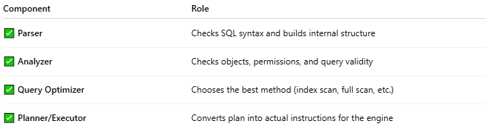
Component | Role
✅ Parser | Checks SQL syntax and builds internal structure
✅ Analyzer | Checks objects, permissions, and query validity
✅ Query Optimizer | Chooses the best method (index scan, full scan, etc.)
✅ Planner/Executor | Converts plan into actual instructions for the engine

💡 Why It’s Important
# Source: AI Source: Provided by: [Data Path: Persons Table -> ID Column: 1, Name_En Column: Motasem Essam] -> From: [ChatGPT] on [6/10/2026]
- Performance: A good optimizer can make a slow query run 100× faster
- Security: Prevents execution of invalid or unauthorized queries
- Correctness: Ensures results match the query’s intent

🧠 Real-World Insight
# Source: AI Source: Provided by: [Data Path: Persons Table -> ID Column: 1, Name_En Column: Motasem Essam] -> From: [ChatGPT] on [6/10/2026]
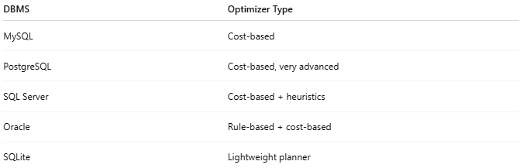
DBMS | Optimizer Type
MySQL | Cost-based
PostgreSQL | Cost-based, very advanced
SQL Server | Cost-based + heuristics
Oracle | Rule-based + cost-based
SQLite | Lightweight planner

📌 Summary
# Source: AI Source: Provided by: [Data Path: Persons Table -> ID Column: 1, Name_En Column: Motasem Essam] -> From: [ChatGPT] on [6/10/2026]
The Query Processor is the smart part of the DBMS that interprets your SQL, optimizes it, and helps the engine execute it efficiently and accurately.

